# DS804 - Assignment 1

* By Dikshant Joshi

Q1)

* **Summary column**

Step 1 : Cleansing of Data.

Step 2 : Duplicated summary column.

Step 3: Renamed duplicated Summary Column from Summary-copy to summary_count.

Step 4: Replaced null values with empty space in summary_count column.

Step 5: Added custom column with summary_count_number_words name and function : List.Count(List.RemoveItems(Text.SplitAny([#"summary_count"],"#(tab) #(lf)"),{""})) Graphical user interface, text, application, email

* **Space column**

Followed the same above steps .

* **Description**

Followed the same above steps.

* **Neighbourhood Overview**

Followed the same above steps.

Q2)

* **Calendar_updated**

Step 1: Duplicated Calendar_updated column.

Step 2: Replaced null values with empty space in Calendar_updated-copy column.

Step 3: Added custom column with Calendar_updated_weeks name and function :

if Text.Contains([#"calendar_updated"], "months")

then

Number.FromText(

Text.Select(

[#"calendar_updated"],{"0".."9"})

)*4

else if Text.Contains([#"calendar_updated"], "weeks")

then Number.FromText(

Text.Select([#"calendar_updated"],{"0".."9"})

)

else if Text.Contains([#"calendar_updated"], "a week ago")then 1

else 0

Q3)

* **Zipcode**

Step 1: Duplicated Zipcode column.

Step 2: Changed Zipcode data type to text

Step 3: Added custom column with Zipcode_corrected name and function :

if Text.Length([#"zipcode - Copy"]) = 4

then Text.PadStart([#"zipcode - Copy"],5,"0")

else [#"zipcode - Copy"]

Q4)

* **Host Since**

Step 1: Added custom column with host_since_day name and function:

Date.DayOfWeekName([#"host_since"],"en-US")

Step 2: Added custom column with host_since_month name and function:

Date.MonthName([#"host_since"],"en-US")

Step 3: Added custom column with host_since_year name and function :

Date.Year([#"host_since"])

* **Host_Since_Duration_Days**

Step 1: Created a new column with function :

Host_Since_Duration_Days = DATEDIFF(listings[host_since],TODAY(),DAY)

Q5)

* **Host Location**

Step 1: Duplicated host_location column

Step 2: Added custom column with Custom.1 name and function, to complete the given location so that data is clean:

if [#"host_location - Copy"] = "Boston, MA" then "Boston, Massachusetts, United States"

else if [#"host_location - Copy"] = "Boston, Massachusetts" then "Boston, Massachusetts, United States"

else if [#"host_location - Copy"] = "PK" then "Pakistan"

else if [#"host_location - Copy"] = "ID" then "Indonesia"

else if [#"host_location - Copy"] = "TN" then "Tennessee, United States"

else if [#"host_location - Copy"] = "Roslindale (part of Boston), MA" then "Boston, Massachusetts, United States"

else if [#"host_location - Copy"] = "Massachusetts" then "Massachusetts, United States"

else if [#"host_location - Copy"] = "Texas" then "Texas, United States"

else if [#"host_location - Copy"] = "US" then "United States"

else if [#"host_location - Copy"] = "CN" then "China"

else if [#"host_location -Copy"] = "Boston, From Jamaica " then "Boston, Massachusetts, United States "

else [#"host_location - Copy"]

Step 3: Added custom column with Custom.2 name and function, to count number of commas in column Custom.1:

List.Count( Text.ToList(Text.Select([Custom.1], ",")))

Step 4: Added custom column with Custom.3 name and function, to make the number of delimiters equal in column Custom.1 with the help of column Custom.2:

if [Custom.2]=0 then ",,"& [Custom.1]

else if [Custom.2]=1 then ","& [Custom.1]

else [Custom.1]

Step 5: Split the column Custom.3 and rename the columns generated after splitting.

Q6)

* **Host Response Time**

Step 1: Duplicated host_response_time column.

Step 2: Removed null values in host_response_time – Copy column with Host_Response_Time_Null.

Step 3: Created an Index column

Step 4: Pivot the host_response_time – Copy, replaced null values with 0 and renamed all the columns appropriately.

* **Host is Superhost**

Followed the same above steps as in Host Response Time

* **Host Identity Verified**

Followed the same above steps as in Host Response Time

* **Host has profile pic**

Followed the same above steps as in Host Response Time

* **Host Verification**

Step 1: Duplicated host_verification column.

Step 2: Removed [,],’ in host_verification – Copy column.

Step 3: Replaced null value in host_verification – Copy column with host_verification_null.

Step 4: Created an index column

Step 5 : Pivot the host_verification – Copy, replaced null values with 0.

* **Amenities**

Followed same steps as that in Host Verififcation.

Q7)

* **Boston Neighbourhood Data**

Step 1: Imported the Boston Neighbourhood Data into Listings.

Step 2: Cleaned the data

* Removed unwanted top rows and bottom rows from each table i.e.; Age, Per Capita Income, Housing Tenure, Poverty Rates, Race and Ethnicity
* Made the top row as header
* Final cleaned data looked like the following:

Age

Housing Tenure

Per Capita Income

Poverty Rates

Race and Ethnicity

Step 3: Resolved the differences between neighbourhood column in the listings table and the Boston data by duplicating the neighbourhood_cleansed column in listings data and making changes as following:

• Chinatown & Leather District = Downtown

• Bay Village=South End

• Longwood Medical Area=Longwood

Renaming the column as Neighbourhood_join

Step 4: Creating a fact table to link Boston data to listings data

* Added the Neighbourhood_join column as a new query.
* Removed duplicates from the column.
* Transformed query into the table using To Table tool.
* Renamed the table as Fact Table with column as Neighbourhood_join
* Saved everything and closed the power query.

Final listings workbook will look like the following.

Q8)

* **Creating visualizations in Power BI**

Step 1: Open Powe BI and select model on the left pane.

Step 2: Click on get Data and load the listings workbook into the Power BI.

Step 3: Update the relationship between fact table and all the other tables as following:

* Listings[Neighbourhood_join] -> FactTable[Neighbourhood_join]
* Per Capita Income[Neighbourhood] -> FactTable[Neighbourhood_join]
* Age[Neighbourhood] -> FactTable[Neighbourhood_join]
* Housing Tenure[Neighbourhood] -> FactTable[Neighbourhood_join]
* Race and Ethnicity[Neighbourhood] -> FactTable[Neighbourhood_join]
* Poverty Rates[Neighbourhood] -> FactTable[Neighbourhood_join]

Step 4: Add reviews data set and create relationship with that as follows:

* Listings[id] -> reviews[listing_id]

The final model will look like the following:

1. **Do owners from more affluent neighbourhoods use more words to describe their properties?**

Ans- To answer this question I used two clustered column charts as follows:

Count of words vs Neighbourhood

Average of Per Capita Income vs Neighbourhood

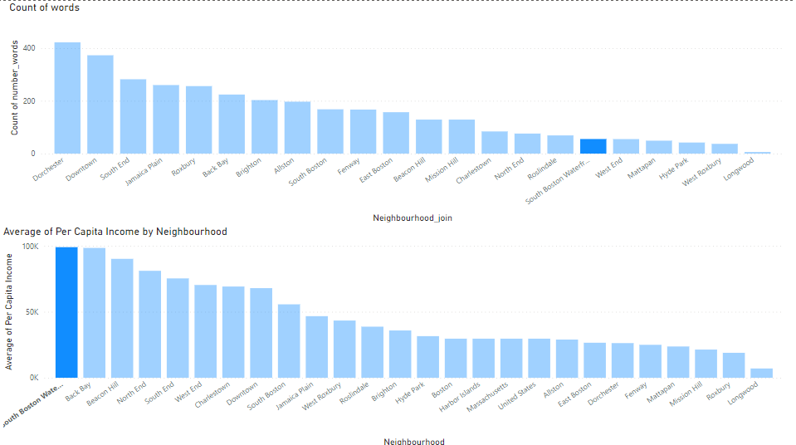

This clearly depicts that more affluent neighbourhood does not use more words to describe their properties.

1. **What percentage of listings were updated between 1-10 weeks?**

Ans – For this I created two tables with columns count of id, calendar_updated_weeks. In one table I applied filter for weeks less than equal to 10. In other table I calculated total listings updated.

So according to this the percentage of listings that were updated between 1-10 weeks is (1729/3440)*100 = 50.2616%.

1. **Do any zip codes have more Superhosts than non Superhosts? If so, which Zip codes are they?**

Ans – For this I used a line chart with zipcode on X-axis and sum of host_is_superhost_t , sum of host_is_superhost_f on Y-axis.

It clearly depicts that at 3 points number of Super hosts is greater than number of Non-super hosts. Zip codes for those points are:

02129, 02136, 02199

1. **In which month of the year do the fewest number of people become hosts?**

Ans – For this I used clustered column chart with count of host_since on Y-axis and host_since month on X-axis.

It clearly shows that in the month of April the fewest number of people became hosts (167).

1. **What proportion of the Superhosts in the United States do host from California constitute?**

Ans – For this I used Donut Chart with legend as host_location_state, Values as Count of Host_is_superhost_t, and details as host_location_country and specified United States in filter.

This tells us that 3.39% (97 Superhosts) host from California state.

1. **Is the** **proportion of hosts from Massachusetts who respond within an hour, larger the proportion of hosts from California who respond within an hour? Show** **different host response times across all the states.**

Ans – For this I used donut chart with legend as host_response_time, Values as Average of Host_response_rate, and details as host_location_state and specified California, Massachusetts in filter.

The chart tells us that proportion of hosts from Massachusetts who respond within an hour (97.42%) is larger the proportion of hosts from California who respond within an hour (95.27%).

Below is the different host response times across all the states

1. **For listings whose price is between $1 and $500 show the number have pools and hot tubs. Property prices should be grouped shown in increments of $50**

Ans – For this I used clustered column chart with price on X-axis and No. of Pool and No. of Hot tuns on Y-axis. To show the listings whose price is between $1 and $500 I applied a filter on price . To group the Property prices shown in increments of $50 I chose New group and specified the Bin Size as $50.

My final visualization looked like the following:

1. **Generate summary statistic(Average, Minimum, Maximum, Standard deviation, variance, median, count) for the following columns and interpret your output [price],[review_scores_rating],[description_numberofWords],[number_of_reviews],[host_total_listings_count**

Ans – For this I created different tables for different column Statistics as following visual shows.

1. **Generate a correlation matrix for each of the following columns and interpret your output [price],[review_scores_rating],[description_numberofWords],[Total Population],[Median Age],[Per Capita Income],[number_of_reviews],[host_total_listings_count],[host_response_time_within an hour].**

Ans:

Step 1:Merged Age,listings and Per Capita Income table into one table merge.

Step 2: Created an index for the Merge table.

Step 3: Created a table Merge_pivot with source = merge and Unpivoted other columns.

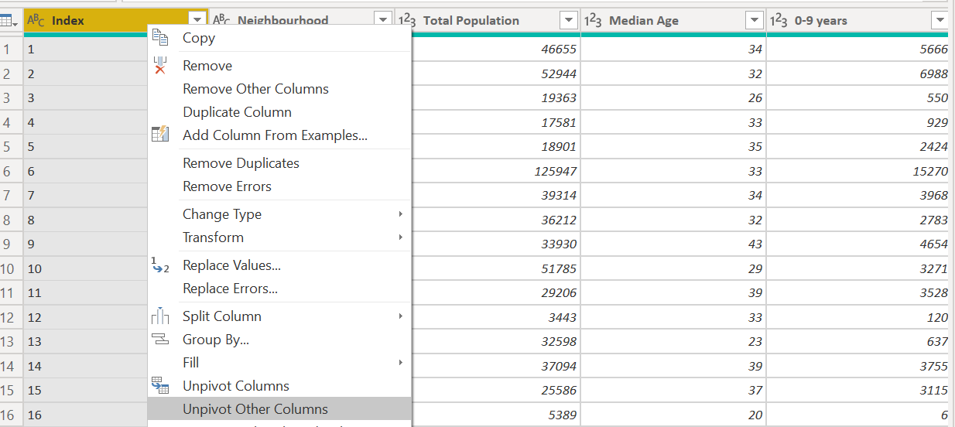

Step 4: Filtered the rows for which correlation is required.

Step 5: Created 2 tables Attribute row, Attribute column with source as Merged_pivot. Select the attribute column and select remove other columns.

Step 6: Remove duplicates .

Step 7: Filtered the rows required for the correlation plot. Close and apply

Step 8: Created measures for correlation(n,X,XY,Y,X2,Y2 and correlation_coeff). Following are the code:

* XY =

VAR CurrentX = SELECTEDVALUE('Attribute row'[Attribute])

VAR CurrentY = SELECTEDVALUE('Attribute column'[Attribute])

VAR VIRTUAL =

SUMMARIZE(

    'Merge_pivot',

    'Merge_pivot'[Index],

    "X", CALCULATE(MAX('Merge_pivot'[Value]),'Merge_pivot'[Attribute] = CurrentX),

    "Y", CALCULATE(MAX('Merge_pivot'[Value]),'Merge_pivot'[Attribute] = CurrentY)

)

RETURN

SUMX(

    VIRTUAL,

    [X] * [Y]

)

* X =

VAR CurrentX = SELECTEDVALUE('Attribute row'[Attribute])

VAR CurrentY = SELECTEDVALUE('Attribute column'[Attribute])

VAR VIRTUAL =

SUMMARIZE(

    'Merge_pivot',

    'Merge_pivot'[Index],

    "X", CALCULATE(MAX('Merge_pivot'[Value]),'Merge_pivot'[Attribute] = CurrentX),

    "Y", CALCULATE(MAX('Merge_pivot'[Value]),'Merge_pivot'[Attribute] = CurrentY)

)

RETURN

SUMX(

    VIRTUAL,

    [X]

)

* X^2 =

VAR CurrentX = SELECTEDVALUE('Attribute row'[Attribute])

VAR CurrentY = SELECTEDVALUE('Attribute column'[Attribute])

VAR VIRTUAL =

SUMMARIZE(

    'Merge_pivot',

    'Merge_pivot'[Index],

    "X", CALCULATE(MAX('Merge_pivot'[Value]),'Merge_pivot'[Attribute] = CurrentX),

    "Y", CALCULATE(MAX('Merge_pivot'[Value]),'Merge_pivot'[Attribute] = CurrentY)

)

RETURN

SUMX(

    VIRTUAL,

    [X] * [X]

)

* Y^2 =

VAR CurrentX = SELECTEDVALUE('Attribute row'[Attribute])

VAR CurrentY = SELECTEDVALUE('Attribute column'[Attribute])

VAR VIRTUAL =

SUMMARIZE(

    'Merge_pivot',

    'Merge_pivot'[Index],

    "X", CALCULATE(MAX('Merge_pivot'[Value]),'Merge_pivot'[Attribute] = CurrentX),

    "Y", CALCULATE(MAX('Merge_pivot'[Value]),'Merge_pivot'[Attribute] = CurrentY)

)

RETURN

SUMX(

    VIRTUAL,

    [Y] * [Y]

)

* Y =

VAR CurrentX = SELECTEDVALUE('Attribute row'[Attribute])

VAR CurrentY = SELECTEDVALUE('Attribute column'[Attribute])

VAR VIRTUAL =

SUMMARIZE(

    'Merge_pivot',

    'Merge_pivot'[Index],

    "X", CALCULATE(MAX('Merge_pivot'[Value]),'Merge_pivot'[Attribute] = CurrentX),

    "Y", CALCULATE(MAX('Merge_pivot'[Value]),'Merge_pivot'[Attribute] = CurrentY)

)

RETURN

SUMX(

    VIRTUAL,

    [Y]

)

* CORRELATION COEFF =

DIVIDE(

    [N]*[XY] - [X]*[Y],

    SQRT(

        ([N]*[X^2] - [X]^2)*([N]*[Y^2]-[Y]^2)

    )

)

* n = DISTINCTCOUNT(Merge_pivot[Index])

Step 9: Created a matrix with row as Attribute_row, column as Attribute_column and values as Correltion_coeff. Following is the Correlation table which we will get:

Q9)

* **Creating a Dashboard**

1)Superhost: Created a donut chart with **legend** as host_is_superhost and **values** as count_of_host_response_rate. Also selected label contents as Data values, Percent of total.

2)Count of comment vs month : Created a clustered column chart with **X-axis** as date-Month and **Y-axis** as Count of comments.

3)Comments :Created a word cloud with **category** as comments Also created a card with **fields** as count of comments.

4)Price by location : Created a Map with **latitude** as latitude and **longitude** as longitude and **Bubble size** as Average of Price. Also created a function for **bubble colors** as shown and created a card with **category** as Average of Review_Score_rating.

5)Neighbourhood, Review Score and Daily Price: Created a slicer for all three with **field** as Neighbourhood_join,price,review_score_rating respectively. Also added a **filter** for Daily price in price as follows to display only a range of price. For Neighbourhood selected dropdown as the **type** of slicer.

Finally did some text editing to display the dashboard as was displayed in the question. Final dashboard looked like the following:

